Name :- Purushottam Kumar

ID :- 2041

MCA I-Sem (R)

Submission Date :- 02-Feb-2021

**Python Lab session 6 (01-02-2021)**

**Assignment**

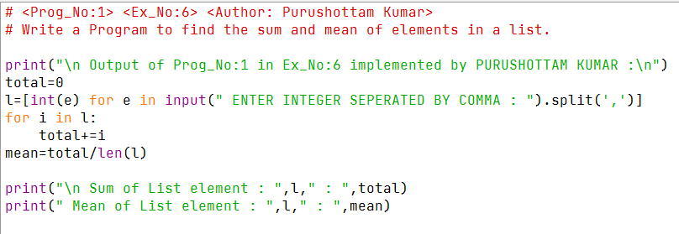

**( Program – 1 )**

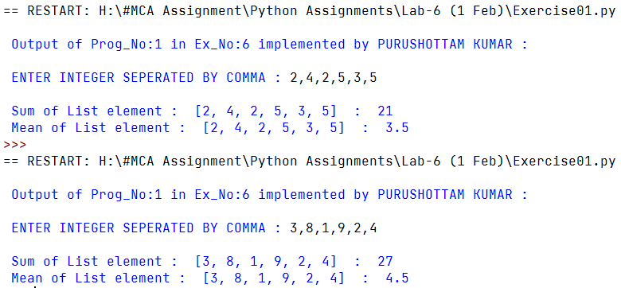 **OUTPUT**

**( Program – 2 )**

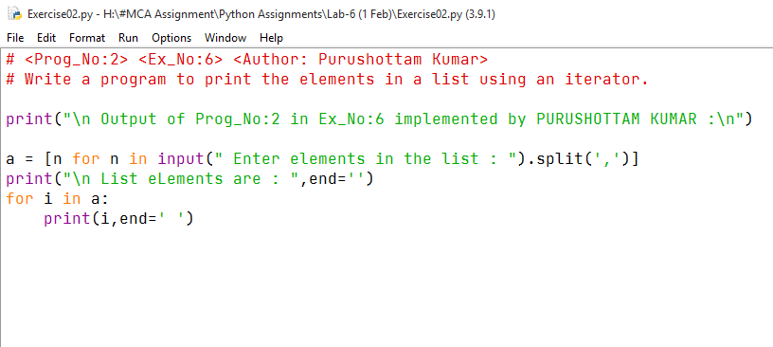

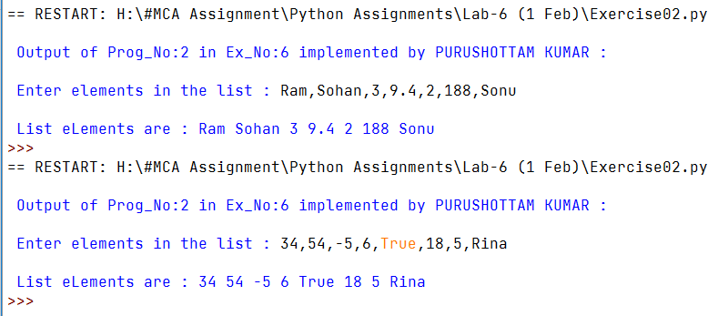 **OUTPUT**

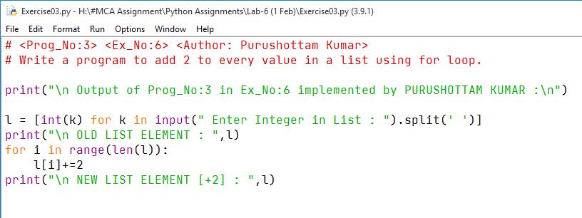

**( Program – 3 )**

**OUTPUT**

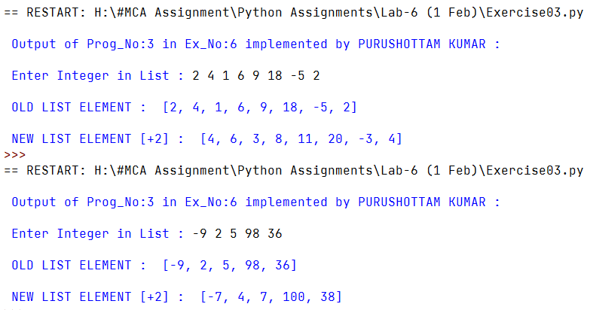

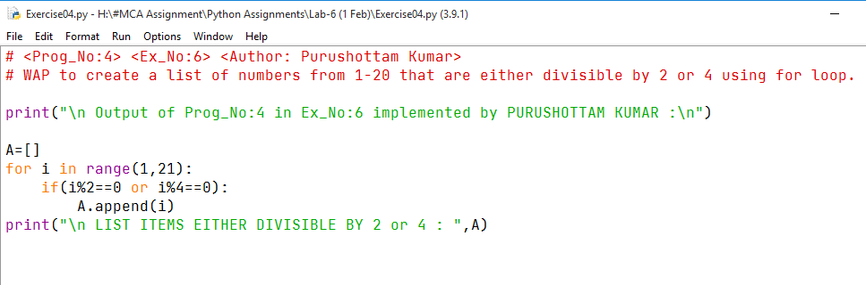

**( Program – 4 )**

**OUTPUT**

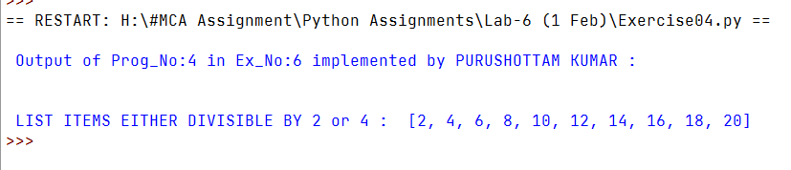

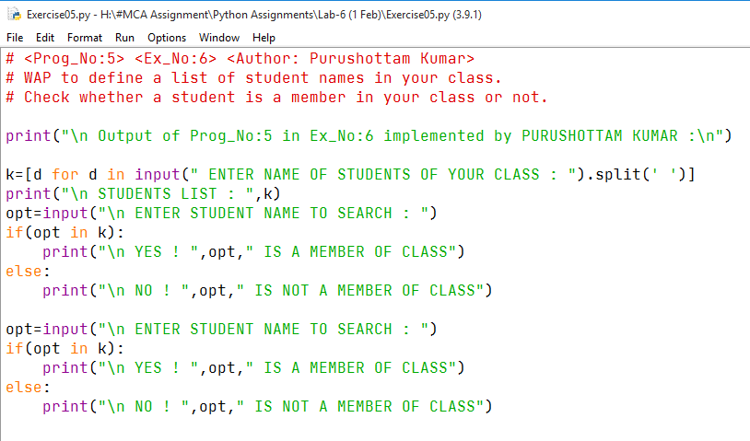

**( Program – 5 )**



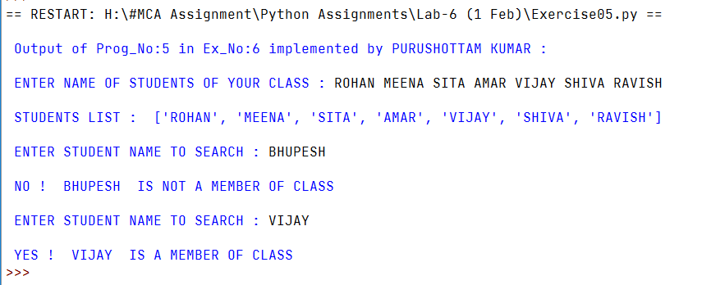

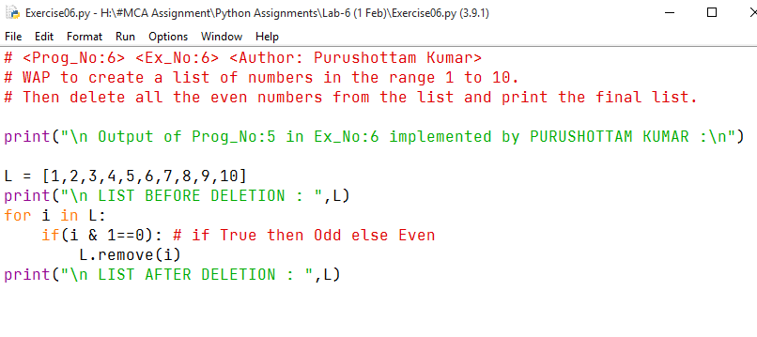

**( Program – 6 )**



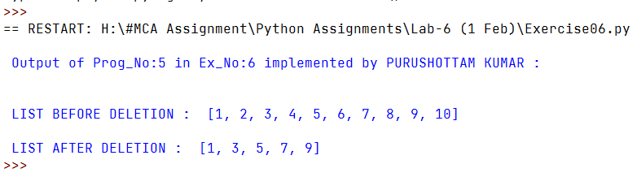

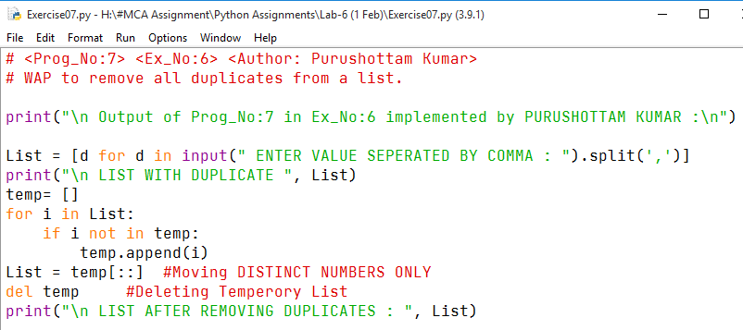

**( Program – 7 )**



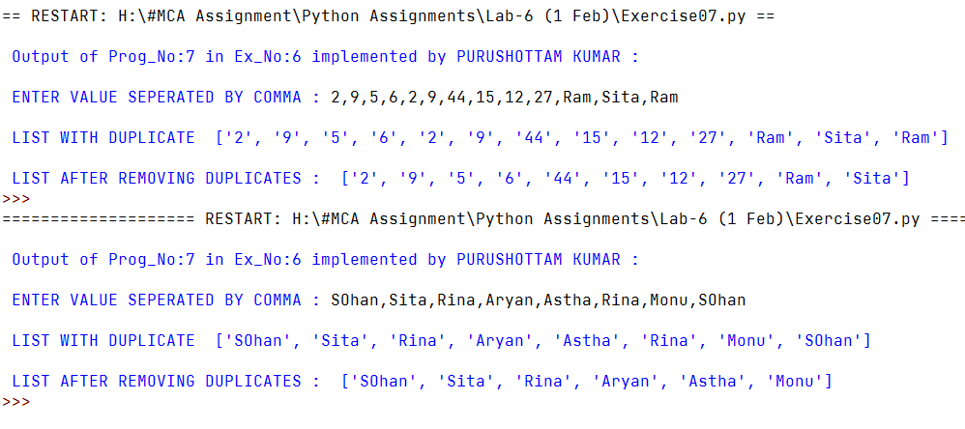

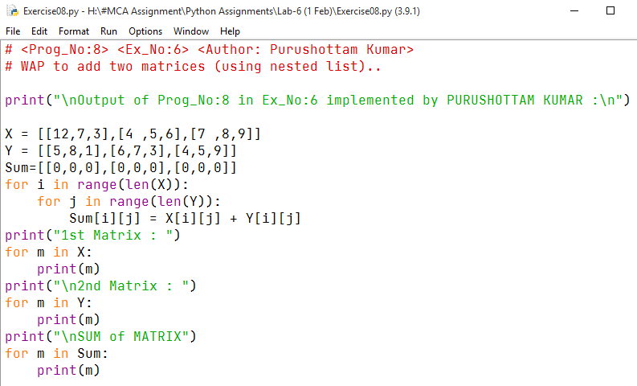

**( Program – 8 )**

